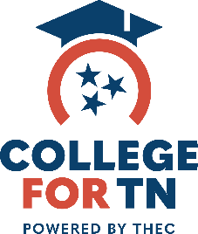
College Fair Tip Sheet

Before the Fair

- Think about what you’re looking for in a college.
  - Do you want to attend an extra-large, large, medium or small size school?
  - What majors are you interested in?
  - Do you want to go to an urban, suburban or rural school?
  - Do you want to attend a 2-year, 4-year, single sex or religiously affiliated school?
  - Do you want to participate in athletics, clubs, fraternities or sororities, or special programs such as study abroad or cooperative education?
- Research the colleges that are attending the fair to see which ones best fit your
preferences.
- Make a list of questions to ask college representatives. Try to think of questions that are insightful and are not easily answered in the college’s brochure or website.
- Bring a resume and/or card with your name, address, high school, year of graduation, email address, intended major, and activities to give to the representative.

At the Fair
- Pick up a fair directory and bag for all of the college materials you collect. Military branches often provide bags if they are not provided by the host.
- Visit schools that match or are the closest match to your preferences.
- Ask the same questions to each college representative you visit (it will help you to compare them).
- Make sure to fill out an inquiry card to let the college know you were in attendance (or give them a pre-printed card you brought with you). This will enable you to get on their mailing list.
- Make notes about the information you found most interesting or helpful.
- Be adventurous. Do not just talk to the “well known” schools.
- Attend an information session that is offered to gather information about the college
search process, financial aid, or whatever topics are available.

After the Fair
- Review information (catalogs and view books) to gather more information and help narrow down your choices.
- Send a thank you note or email to the college representatives you talked with as a way to reinforce your interest in the school.

Adapted from National Association for College Admission Counseling (NACAC)

