TN Path to College: Who am I?

The most important step in defining your path to college is to start with yourself. What activities and unique parts of your identity make you a remarkable individual?
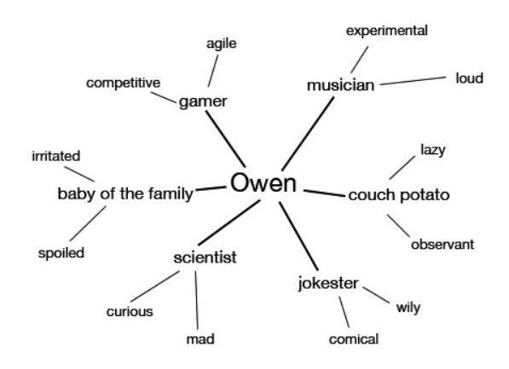
Mind Maps Complete a mind map with your first name in the center. Check out Owen’s student example:

In the space provided, ask yourself the following questions and how they relate to the center of the map, you!
- What makes you different?
- How do others perceive you?
- What activities bring you to life?
- In what activities do you spend the most time, effort, and energy?
- Where do you feel the most safe and supported?
- How do you share your gifts and talents with others in your community?

Name:

