Social Media 101
Social media is a fun, exciting way to share great news (and great photos) from your Path to College Events. There are many platforms to choose from, each of which has a different format for sharing information and can help you reach a different audience. For example, if you’re sharing a photo that you’re hoping your students will connect with, Snapchat or Instagram are great places to start. Sending a short message? Try Twitter.

If you’re new to Path to College, and new to social media, we recommend you pick one social media platform (for example, Facebook) and concentrate on posting all of your news and photos on that page.

Below you’ll find an overview of popular social media platforms and their pros and cons. Most importantly: verify your school’s rules about social media and students before you start any social media pages or campaigns.
Instagram: Instagram is a social media platform that focuses on photo sharing. Users upload a photo to their account and write captions that incorporate hashtags (#) which allow for others to search and find their photos.
Pros: Instagram is very visual and has a younger user base, so you’re more likely to connect with students. Cons: You cannot post a message without a photo, so this is not best for a quick announcement.
Snapchat: Of the “big four” social media platforms, Snapchat is the newest and also has the youngest audience. Users share disappearing photos either amongst their friends or to a “story”. Pros: Students use Snapchat, with many logging in throughout the day. Cons: While they use the app, most users only utilize the person to person picture sharing and don’t explore images from brands or pages. Students would often rather send one another “snaps” than seek out content.
Facebook: Facebook has the largest user base of these four platforms, in part because it has been around the longest. Users can share posts that are just texts, or text plus pictures, emojis, even emotional reactions. Pros: Facebook can be more “user friendly” for adults. Setting up a page and connecting with others is any easy process. Cons: Fewer students are on Facebook, so you’re more likely to connect with their parents than students directly.

Twitter: Twitter keeps messages short and sweet with a 280 character limit. Users can share photos or just text and it is often used to chronicle events as they happen. Pros: Just as Instagram hashtags are searchable, using a
hashtag (#) allows your tweet to join a conversation and show up when others search. For example, #TNCollegeAppWeek has great pictures from previous events. Cons: Again, fewer students use Twitter as opposed to individuals over 18.

Social Media Reach
Social media is a fun tool that can help you engage your audience in a way that traditional media (print, TV, and radio) cannot. If you are interested in trying to analyze the “reach” or impact of your social media work, these examples can help you understand what free analytics exist on Twitter and Facebook.

Understanding a Tweet’s Social Media Reach (Twitter)

In this example, the content is “We have received a $24.5M grant to expand GEAR UP! “TN has become a national model for college access and success.” share.s/1VEjNh The tweet received 54 likes.
The tweet received 25 retweets.
For advanced analytics, you can click on this icon below your tweet:
A window will appear showing you the number of impressions (number of people who saw your tweet) and engagements (number of people who interacted with your tweet, i.e., clicked a link, liked it or retweeted it).

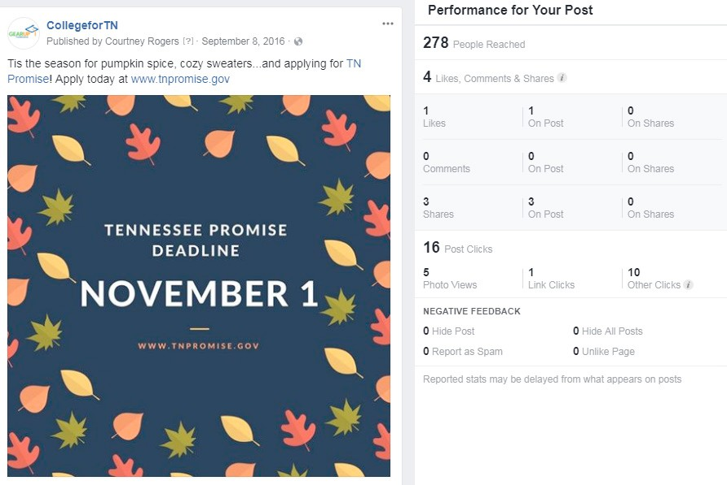
Understanding a Facebook Post’s Social Media Reach

In this example, the content is “Tis the season for pumpkin spice, cozy

sweaters...and applying for TN Promise! Apply today at www.tnpromise.gov
The post received 1 like. The post received 3 shares.
In this window, you can see additional information such as the number of people reached and the number of times someone clicked on your post.

Creating Google Alerts
If you send out a press release or media advisory, you’ll want to know when something about your event gets published. Google alerts are an easy and convenient way to ensure you see when your school is featured in the news. These directions have been adapted from the Google Help Forum.

Create an Alert
- Sign-in to your Google account.
- Type in the website https://www.google.com/alerts.
- In the box at the top, enter the words you would like Google to alert you of when news appears. We suggest you use quotation marks for your search terms, i.e., “TN FAFSA Frenzy.”
- Click Show Options to update the following: how often you’d like to be notified, the types of sites you’ll see, how many results you want, and which other Google accounts should receive the alert.
- Click Create Alert. You will now get emails whenever Google finds matching search
results.
We suggest that you create multiple alerts to ensure you’re capturing as many mentions of your school’s college access work as possible.
  - “Karns High School”
  - “KHS”
  - “KHS College Signing Day”

