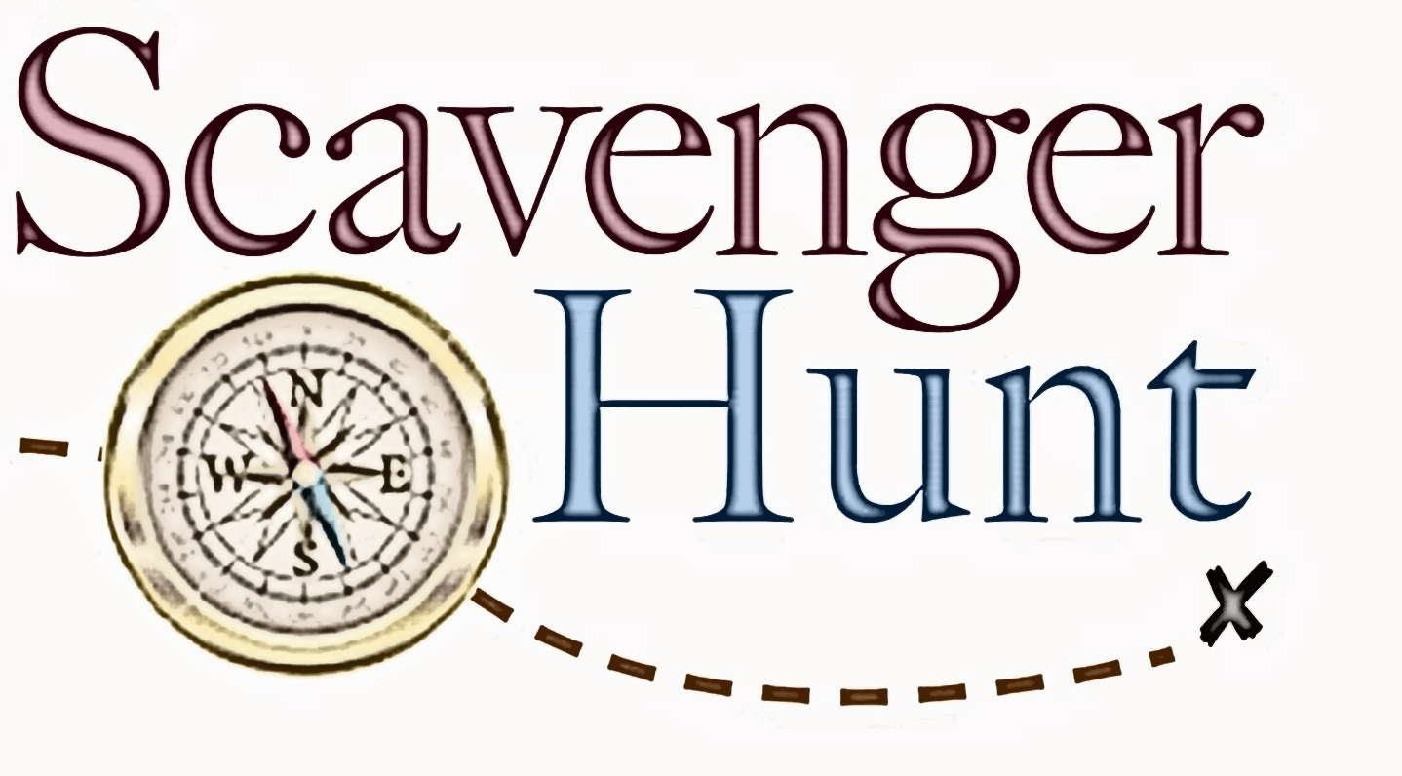
NEXT Guide

Name: ___________________________________

Using your Sophomore NEXT Guide, answer these questions and return to your enrichment teacher.

All correct entries turned in will be entered into a drawing for a door prize!

1.What are three of the websites suggested to research jobs, careers, or career pathways?
2. What are any three benefits of postsecondary education?
3. Where can you earn an associate degree?

4. How many Tennessee Colleges of Applied Technology are located in Tennessee?

5. By 2025, what percentage of jobs in Tennessee will require a postsecondary credential?

6. How many public universities are in Tennessee?

7. What is the highest score possible for the ACT and SAT?

8. What are three benefits of participating in Early Postsecondary Opportunities?

9. Give three examples of Early Postsecondary Opportunities in Tennessee?

10. What is the Tennessee Promise?

11. What is the difference between a loan and a grant?

12. What are the requirements to be eligible for the Tennessee Hope Scholarship?

13. How many community colleges are in Tennessee?
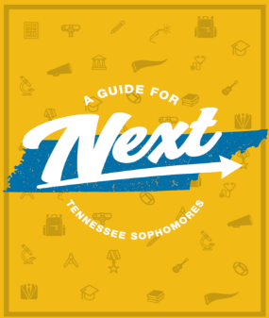
14. What is ROTC?

15. What is meant by a 2 + 2 program?

16. What is the difference between a loan and a grant?

