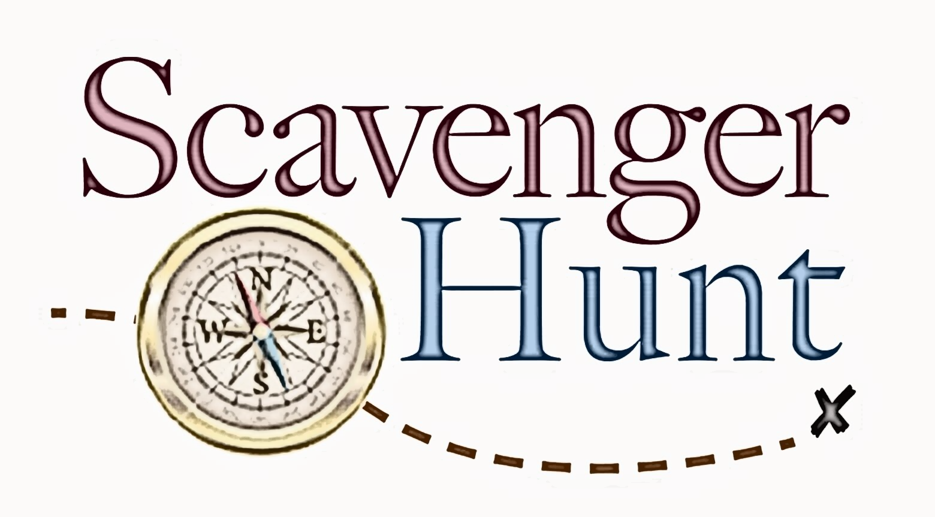
NEXT Guide

Name: ___________________________________

Using your Freshmen NEXT Guide, answer these questions and return to your enrichment teacher.

All correct entries turned in will be entered into a drawing for a door prize!

1. After you complete the “Career You’ve Dreamed Of” activity, how many different career interest areas are identified?
2. What are two characteristics, personal habits, and conflict styles of the “triangle” personality?
3. What are three things you can do to Survive Freshman Year?

4. Where can you earn an associate degree?

5. How many Tennessee Colleges of Applied Technology are located in Tennessee?

6. What is ROTC?

7. What is the difference between a grant and a loan?

8. How many community colleges are in Tennessee?

9. What is Dual Enrollment?

10. What is the Tennessee Promise?

11. What are the requirements to be eligible for the Tennessee Hope Scholarship?

12. What is a grade point average?

13. What is the award amount for the Wilder-Naifeh Technical Skills Grant?
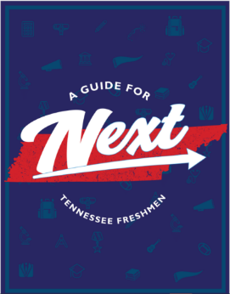
14. What is meant by a 2 + 2 program?

