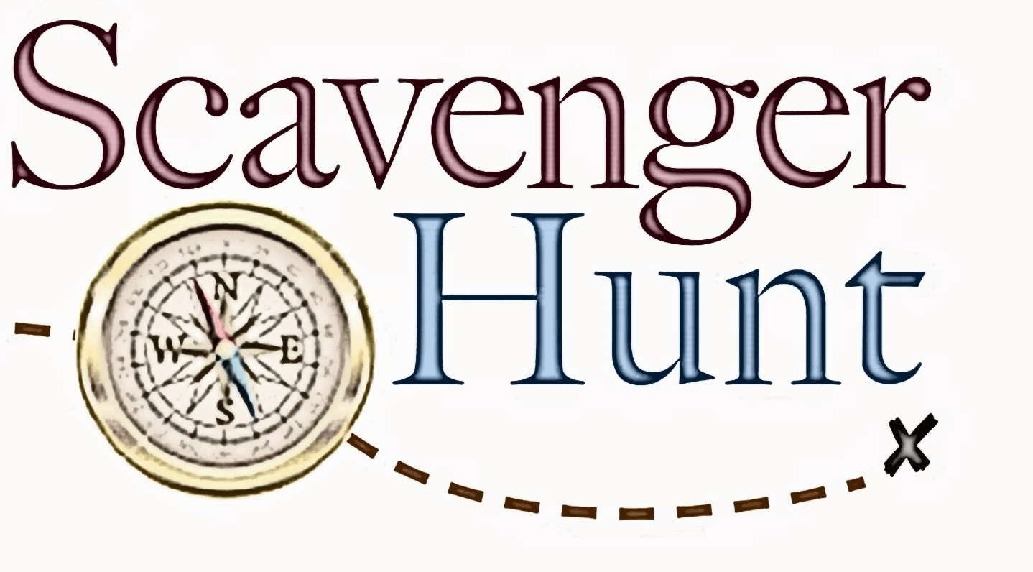
NEXT Guide

Using your Junior NEXT Guide, answer these questions and return to ___________________________

All correct entries received by _________________ will be entered in a drawing for ____________________

1. What’s the highest possible score you can make on the ACT test?
2. What is a Pell grant?
3. What are any three benefits of postsecondary education?

4. Where can you earn an associate degree?

5. How many Tennessee Colleges of Applied Technology are located in Tennessee?

6. How many reading passages are on the ACT test?

7. What is the minimum score you can make to get the Tennessee Hope Scholarship?

8. How many community colleges are in Tennessee?

9. What is Dual Enrollment?

10. What is the Tennessee Promise?

11. How many public universities are located in Tennessee?

12. What are the ACT and SAT tests?

13. What is the award amount for the Wilder-Naifeh Technical Skills Grant?

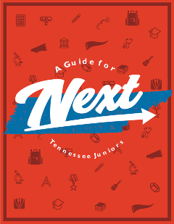
14. What is the name of one Ivy League college or university?

15. What are scholarships?

